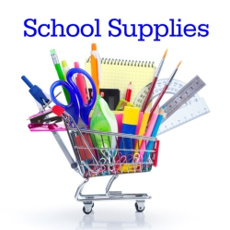

# **Winterset Elementary**

# **2023-2024 Supply List**

# **Primary Specialized Learning Centers –**

**Mrs Darst**

Enclosed you will find the list of school supplies your student will need for this school year. Please send these supplies with your child on the first day of classes!

* 2-4 Big Kindergarten Pencils
* 1 box water colors
* 1 box of 24 crayons
* 1 box Ziplock baggies - any size
* 12 glue sticks
* 1 pack of markers
* 1 box colored pencils
* 3 boxes tissues
* 2 SOLID colored 2 pocket folders (with nothing written on them)
* 1 containers of antibacterial wipes (such as Lysol, etc.)
* 1 pair of Student scissors, blunt point
* 1 3-ring Binder, 1”
* Complete change of clothing
* Diapers and Wipes, if needed